1: For any given application, why not using all software implementation? What are the benefits of using hardware for certain parts of the target application?

2:
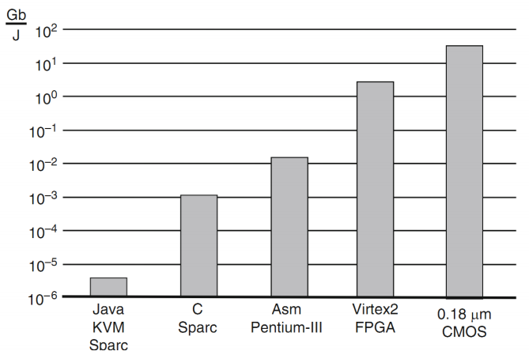
This figure shows the energy efficiency of different implementations of an application. As it illustrates, CMOS implementation has the best energy efficiency. Based on your understanding, use your own words to explain why hardware implementation is so much more energy-efficient than software implementation.

3: List different ways of describing computation.

4: List at least THREE benefits of compressing images in digital camera.

5: The following flow diagram shows the task relationship in our software implementation of digital camera. If we would like to add a new functionality called SCALE, which increases or decreases the size of captured images, where should this task module be added to this diagram? Please add the SCALE module to the following task graph. Please state your reasons for your choice.

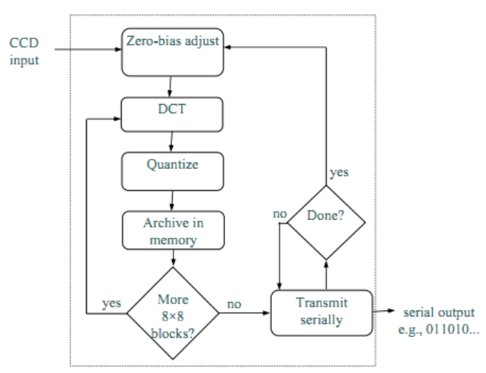

6: For the following state transition diagram, write a verilog implementation.
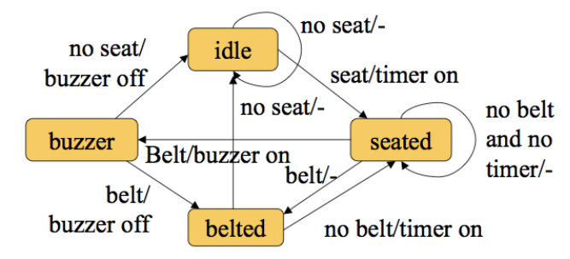

7:
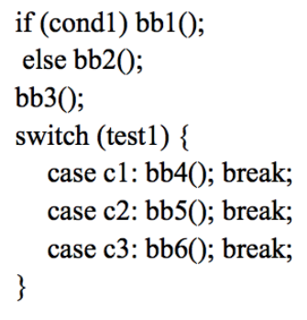

For the above code segment, draw a Control-Data Flow Graph?

8: For the following Control Flow Graph and Data Flow Graph, assume each operation (in yellow circle) takes exactly one clock cycle. Draw a scheduling diagram to achieve the minimum number of clock cycles for all operations.

